Aim : To interpolate the using the Newton Forward Interpolation method.

Theory:
Newton Forward Interpolation Method:
It is a finite difference identity giving an interpolated value between tabulated points in terms of the first value and the powers of the forward difference .
Formula :

Algorithm:
Here we are interpolate the graph using the points by Newton Forward Interpolation Method and we can do this by taking a large number of points between the first and the last point that given and finding the value of f(x) at every point using the Newton Forward Interpolation Method.
This can be done by make first finding the Forward Difference for all given points and then running a loop for all the new points , at first we find the x₀ for every value of x , then using the formula at the function finding the value at that point and write the value in a file.

Program :
program main
implicit none ! declaring the variables

real , dimension(:) , allocatable :: x(:) , y(:) , diff(:)
real :: result , p , d , val , fact
integer :: i , j , k , n , index , row , num_points
logical :: f1,f2

print*, "Enter the number of the given points : " ! getting the number of points
read*, n
if (n <= 0) stop "Invalid entry" ! And validating them

allocate(x(n),y(n),diff((n**n - n)/2)) ! allocating the memory for all arrays
! here we are using the linear array for the forward difference table to saving the memory

print*, "Enter the value of x and y : " ! reading the given points and number of points generated b/w them
print*, "x y"
read*, (x(i),y(i),i=1,n)
print *, "Enter the number of points taking between x0 and xn :: "
read*, num_points
if (num_points <= 0 ) stop "Invalid entry"

inquire(file="givenpoints.dat",exist=f1) ! opening the file for storing the value of given and calculated points
if(f1) then
open(1,file="givenpoints.dat",status="replace")
else
open(1,file="givenpoints.dat",status="new",action="write")
endif
inquire(file="calpoints.dat",exist=f2)
if(f2) then
open(2,file="calpoints.dat",status="replace")
else
open(2,file="calpoints.dat",status="new",action="write")
endif

do i=1,n
write(1,*)x(i),y(i) ! writing the given points in the file
enddo

row = 0
do i = 1,n-1 ! here calculating the forward difference and storing in linear array diff
do j = 1,n-i
if(i==1) then
diff(j) = y(j+1) - y(j)
else
diff(row+j) = diff((row-n+i-1)+j+1) - diff((row-n+i-1)+j)
endif
enddo
row = row + n - i ! this variable row can give ability to change the column of table
enddo

d = (x(n) - x(1))/real(num_points) ! getting the difference between the points we calculating

do k = 1,num_points-1 ! taking a loop for calculating the points
val = x(1) + k*d
index = cal_x0_index(val) ! here we find the index of x0 for a given point val
p = (val - x(index))/(x(2) - x(1))
result = y(index) ! result is the value of f(x) at x
fact = 1 ! for getting the insuit factorial in the formulae
row = 0
do i = 1, n-index
fact = fact*i
result = result + p*diff(row+index)/fact
p = p*(p-i)
row = row + n-i
enddo
write(2,*)val,result
enddo

close(1)

print*, "Simulation is complete"

stop

contains
integer function cal_x0_index(value) ! this is function for calculating the index of
real , intent(in) :: value ! x0 for a given value of x
integer :: k
do k = 1,n
if (x(k) > value) then
cal_x0_index = k-1
return
endif
enddo
stop "Value of x is over the upper limit"
end function cal_x0_index
end program
Output:
Enter the number of the given points :
5
Enter the value of x and y :
x y
1891 46
1901 66
1911 81
1921 93
1931 101
Enter the number of points taking between x0 and xn ::
10000
Simulation is complete

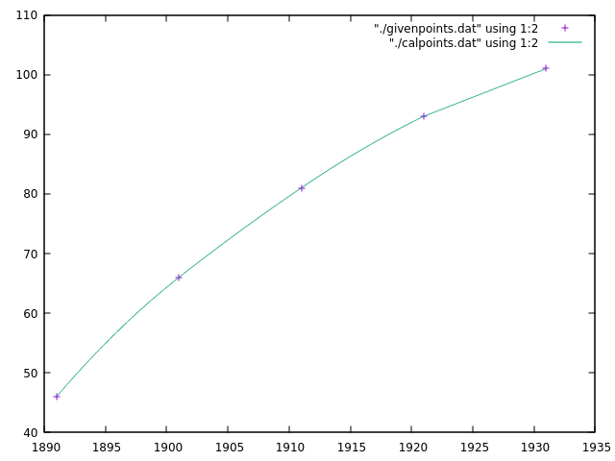
Result :

Flow Chart:
